Certificate of Consecration

To all who shall see these presents, Greetings:

whom the Church judges well qualified for that ministry was this day set aside by consecration to serve as a

**Deaconess**

in The African Methodist Episcopal Zion Church.

She is authorized to minister to the poor, visit the sick, and pray

with the dying, care for the orphan, seek the wandering, comfort the sorrowing, save the sinning, and to perform

all other duties pertaining to her office, so long as life and conduct comport with the Gospel rule and she conforms

to the Discipline of The African Methodist Episcopal Zion Church.

*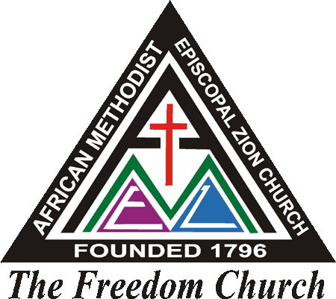***Done on Wednesday, December 13, 2017 in the Year of Our Lord Two Thousand and Sixteen**

*African* Methodist Episcopal Zion Church

“The Freedom Church “

___________________ ___________________

Pastor in Charge President, Board of Deaconess