Certificate of Achievement

Presented to

For your great accomplishments during the 2018-2019 school year

this Monday, December 11, 2017, in the Year of Our LORD Two Thousand Eighteen

*“Trust in the Lord with all of your heart and lean not on your own understanding; in all your ways acknowledge Him and He will make your paths straight” Proverbs 3:5, 6*

*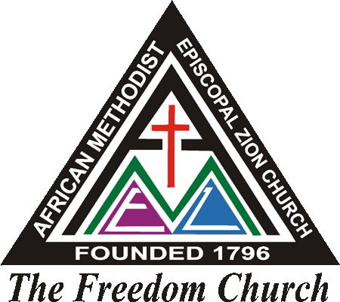 African* Methodist Episcopal Zion Church

“The Freedom Church “

___________________ ___________________

Pastor in Charge Directors of Christian Education